# Sealed Classes

## Overview

This lab will give you an opportunity to define and use sealed classes (and sealed interfaces).

## Step 1: Implementing a sealed hierarchy using records

In IntelliJ, create a new module named student.sealedClasses. In the src folder, implement an inheritance hierarchy as per the UML diagram below. The idea is that FullTimer, PartTimer, and Consultant are the only types of *contract* allowed:

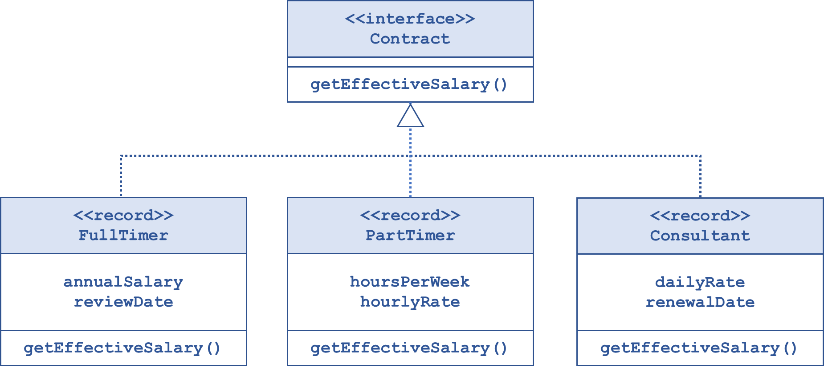

Write some code in main() to create a polymorphic collection of different types of *contract*, and insert various objects into the collection. Then iterate through the collection and pass each element into a function that takes some kind of *contract* object as a parameter and processes it.

## Step 2: Implementing a sealed hierarchy using classes

Now implement another inheritance hierarchy as per the UML diagram below. The diagram indicates that the only allowable types of *vehicle* are:

* Car
* LGV (light goods vehicle)
* HGV (heavy goods vehicle)
* Any kind of commercial vehicle

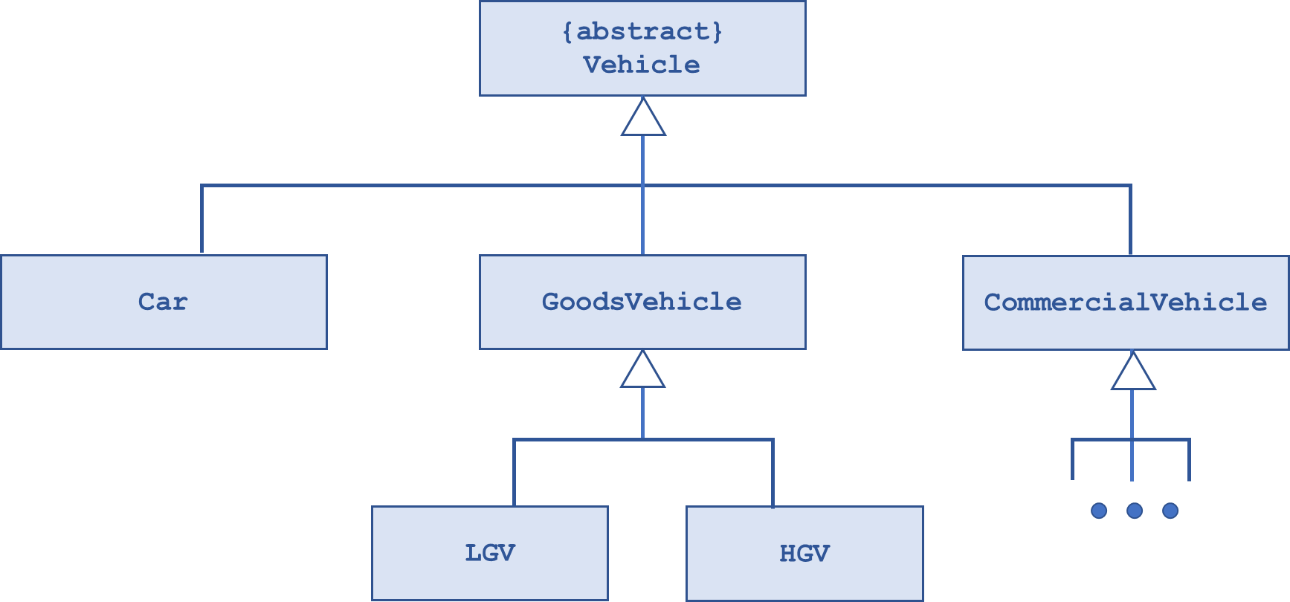

Write some code in main() to exercise this hierarchy 😁.